Course: CA318

Lecturer: Mark Humphrys

Name: victor akinla

Student number: 13374896

AI PROJECT

I declare that this material, which I now submit for assessment, is entirely my own work and has not been taken from the work of others, save and to the extent that such work has been cited and acknowledged within the text of my work. I understand that plagiarism, collusion, and copying are grave and serious offences in the university and accept the penalties that would be imposed should I engage in plagiarism, collusion or copying. I have read and understood the Assignment Regulations set out in the module documentation. I have identified and included the source of all facts, ideas, opinions, and viewpoints of others in the assignment references. Direct quotations from books, journal articles, internet sources, module text, or any other source whatsoever are acknowledged and the source cited are identified in the assignment references. This assignment, or any part of it, has not been previously submitted by me or any other person for assessment on this or any other course of study.

**Analysis of the world:**

The world is quite difficult because the pacman and ghosts gets spawned in random locations. One of these locations is a glitch where the pacman is stuck in a loop going up and down. I cut the program off after 70 images were produced, because the ghosts were just mirroring the pacman.

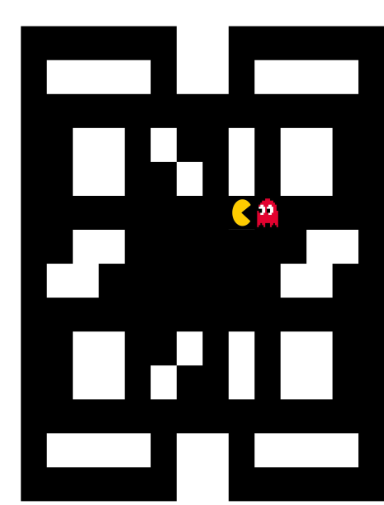 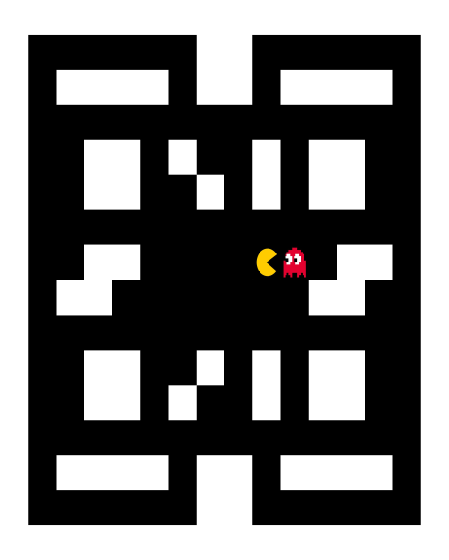

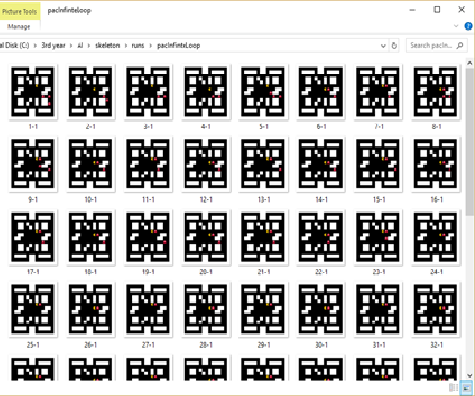

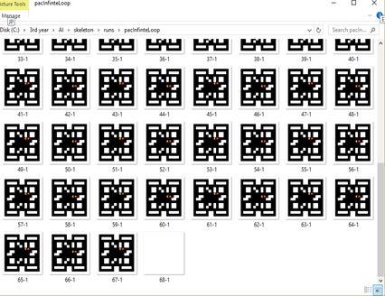

**Bugs:**

**public class victorMind implements Mind**

**{**

**List <Point> illegalArea = Arrays.asList( PacSurvive.get_borders());**

**//====== Mind must respond to these methods: ==========================================================**

**// newrun(), endrun()**

**// getaction()**

I had issues with the get_borders() function. I created an instance of a arraylist to store all the borders. I used an array list because it would be easier to search with because of it contains method. When I ran the code it kept on returning null Pointer exception.

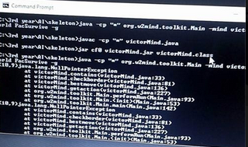

So to fix this issue I decided to create a normal array with the point borders

And use the get_borderlength(); function to iterate through the array. I created my own contains (point [] p1, Point p1, int count) method which took three parameters one for the array, one for the point, and the last parameter represented borderlength().

public class victorMind implements Mind

{

Point[] borders = PacSurvive.get_borders();

int num_borders = PacSurvive.get_borderlength();

**Awkward Situations:**

Pacman does not know how to respond to being cornered by two ghosts which are above it but on different x axis, it tries to move left and right but it movements are mirrored by the two opposing ghosts. They eventually corner him in and the game is over.

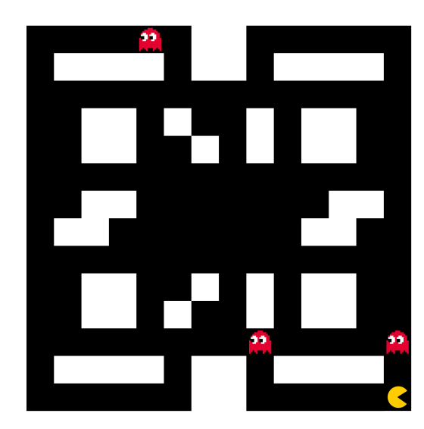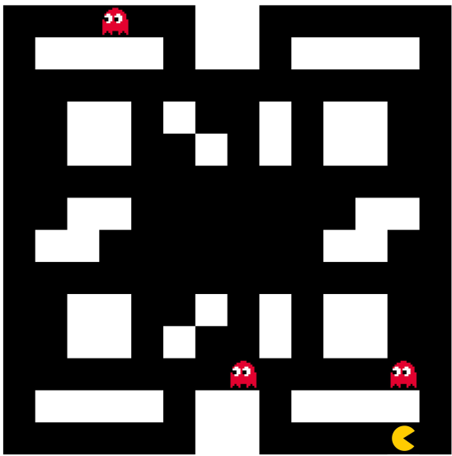

Online stat:

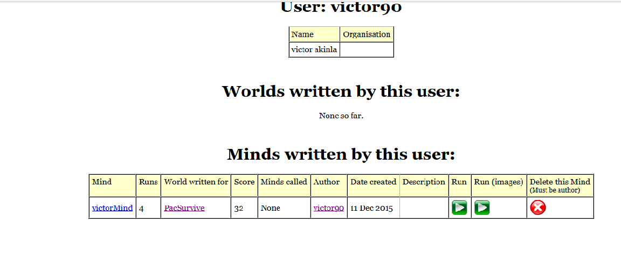

Offline stats:

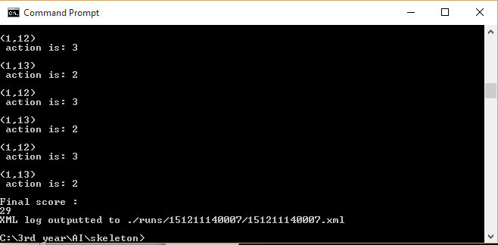

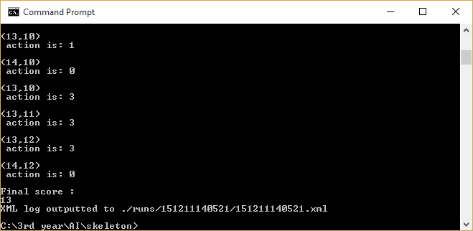

**Approach:**

Pacman checks his position against the position of the closest ghost. The pacman then uses this knowledge to move in the direction that is opposite to the ghost, while checking if there are borders in the way. My checkborder() method returns a number to indicate if the position the pacman is running to has a border, if so the pacman then checks the next free available position and move into that position using the checkborder () method.